IAG DENUCHANGE Workshop
6-9 October 2026
Naxos, Greece
First circular
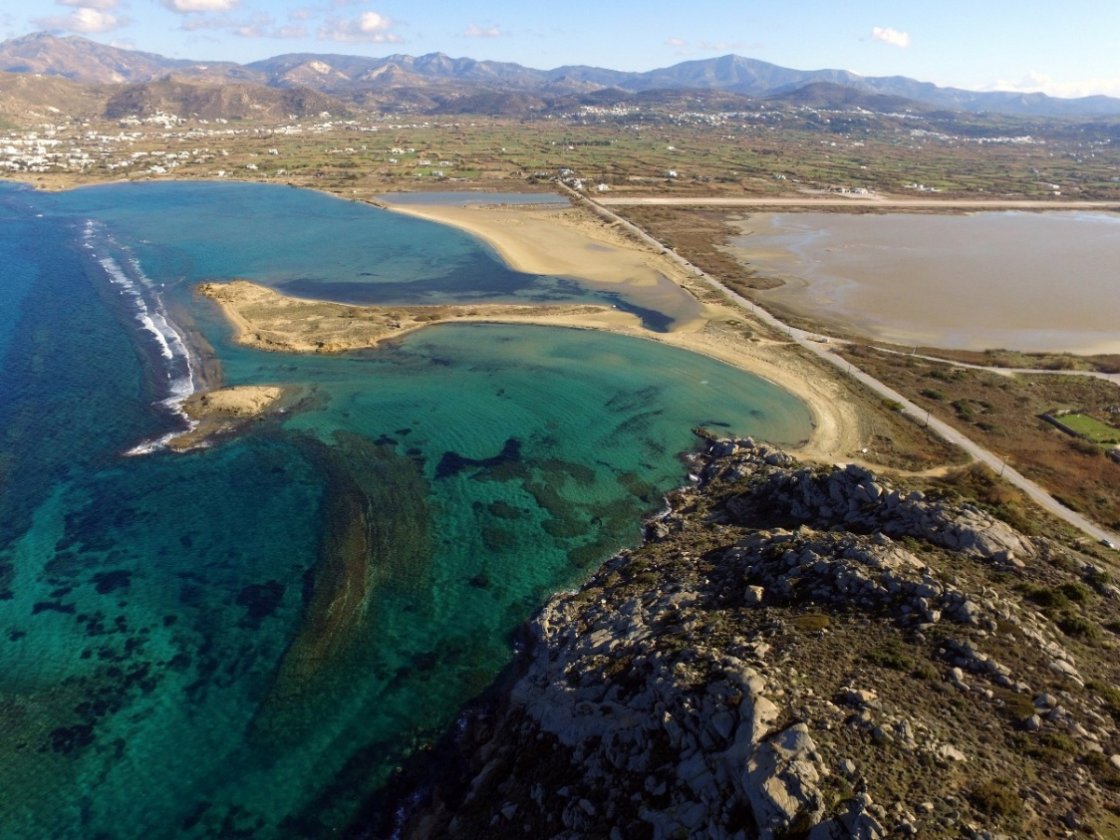
WORKSHOP AIMS AND TOPICS
We are pleased to invite you to take part in the workshop of the IAG-DENUCHANGE Working Group that will take place at Naxos, Greece, on 6-9 October 2026.
The workshop aims to bring together geoscientists, to contribute to an advanced understanding of denudation processes, such as weathering, erosion and mass movements in both coastal and terrestrial environments, their drivers, rates, diversity and variability around the world, and to facilitate future collaborations.
DATES
6-7 October 2026, presentations and poster sessions
8-9 October 2026, field trip
ORGANIZING COMMITTEE
Prof. Evelpidou Niki, Department of Geology & Geoenvironment, National & Kapodistrian University of Athens
Dr. Anna Karkani, Department of Geology & Geoenvironment, National & Kapodistrian University of Athens
Dr. Giannis Saitis, Department of Geology & Geoenvironment, National & Kapodistrian University of Athens

SCIENTIFIC COMMITTEE
Dr. Achim A. Beylich, Geomorphological Field Laboratory (GFL), Selbustrand, Norway
Prof. Niki Evelpidou, Faculty of Geology & Geoenvironment, National & Kapodistrian University of Athens, Greece
Dr. Anna Karkani, Faculty of Geology & Geoenvironment, National & Kapodistrian University of Athens, Greece
Dr. Eliza Płaczkowska, Institute of Geological Sciences, University of Wrocław, Poland
Prof. Nurit Shtober-Zisu, Department of Israel Studies, University of Haifa, Haifa, Israel
Prof. Zbigniew Zwoliński, Institute of Geoecology and Geoinformation, Adam Mickiewicz University in Poznań, Poland.

WORKSHOP REGISTRATION FEES
Regular fee (2 days meeting + 2 days field trip): 450 €
Student fee (2 days meeting + 2 days field trip): 300 €
Regular/Student fee (only 2 days meeting): 100 €
Accompanying person to the field trip: 300 €

The full regular/student fee covers meeting materials, coffee breaks and lunches during the workshop (6-7/10/2026), Workshop Dinner (7/10/2026) and the 2-day field trip.

REGISTRATION FORM AND ABSTRACT SUBMISSION
Please, register and submit your abstract at https://forms.gle/Nz7TP2rviNwt8k437
Please, specify your preference between oral and poster presentation.
Abstracts must not exceed 500 words (not counting abstract title or author string) and must be submitted in English. It is recommended to type the text of the abstract in a Word processing programme in Calibri font size 11. Please rename your file as: Surname_Name_Topic.docx before uploading.

DEADLINES
30 May 2026: Deadline for abstract submission
15 June 3026: Notifications to authors
15 July 2026: Deadline for registration

FIELDTRIP
The post-workshop field trip will take place on 8-9 October 2026 on Naxos Island, dedicated to exploring the critical continuum between catchment dynamics and coastal evolution. A major focus will be placed on the island’s interior to examine drivers of land degradation and desertification. Participants will observe the geomorphological footprint of forest fires, analyze runoff erosion processes, and discuss the impact of agricultural terraces and dams on sediment budgets. Moving from the hinterland to the coast, the itinerary addresses hydro-geomorphological hazards, including flash floods (Peritsis river), before examining coastal pressures. Key stops (Alyko, Laguna, Pyrgaki) will highlight cliff retreat and dune erosion, evaluating the effectiveness of Nature-based Solutions (NbS) for climate adaptation.

